Volunteer Application | 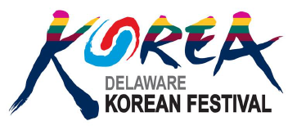
The 2018 Delaware Korean Festival will take place at the Delaware Art Museum (2301 Kentmere Pkwy, Wilmington, DE) on Saturday, September 29, 2018. Volunteers must be 12 years or older.

Contact Information
Name
Address
City / State / Zip
Phone
Email Address

Availability

During which event hours are you available?
Full Event from 10:30 AM to 3:30 PM (5 hours including lunch break)
Partial Event from 10:30 AM to 1:00 PM (2.5 hours)
Partial Event from 1:00 PM to 3:30 PM (2.5 hours)

Interests

Which areas you are interested in volunteering (check all that apply):
Welcome Table / Guest Greeting
Korean Snack Booth
Korean Costume Photo Booth
Write Your Name in Korean Booth (Requires Korean writing ability)
Lunch Tent
Stage Assistance

Benefits
All volunteers will receive the following benefits:
- Volunteer Certificate provided by Delaware Art Museum (Name as provided in this form)
- 2 Free Delaware Art Museum two Admission Passes
- $10 Lunch Voucher (Full Event Volunteer Only)

Thank you for helping with our Korean Festival!

